Subscribe to DeepL Pro to edit this document.
Visit www.DeepL.com/pro for more information.

Creation of an SD&RS label

(sustainable development and corporate social responsibility)

in the general engineering curriculum booklets

Context

- May 17, 2018: appointment of Frédéric Roberjot as the establishment's DD&RS manager ("green plan").

- April 4, 2019: creation of a DD&RS commission with 4 teachers/researchers, 1 student.

- 1er July 2019: vote by the Board of Directors on the 25 commitments as part of its sustainable development and corporate social responsibility objectives: "Objectif Terre".

In 2019-2020, a study project (PE) was carried out to identify the elements present in the generalist engineering curriculum that contribute to the acquisition of skills by students with a view to meeting DD&RS objectives. In 2017, and then again in 2019, the studies department carried out a summary of the hours allocated to DD&RS issues. These surveys showed that a very large number of training actions are linked to the theme.

Objective and proposal

In order to make the actions carried out at the school around SD&RS issues more visible, more explicit communication needs to be put in place.

As a first step, it is proposed to indicate a label on each training action according to the following two levels:

- Level 1: Activity contextualized by SD&RS issues

- Level 2: Certain activities focused on an SD&RS issue

- Level 3: All activities focused on an SD&RS issue

These labels will be visible on the training program, which will be available on the Internet (in HTML format), as well as in the PDF booklets produced (approved each year by the Board of Studies for validation of the models).

The Board of Studies meeting on April 29 unanimously approved this provision.

Practical implementation
Each activity manager positions the label on Scol.ec-lyon.fr, see screenshot below:
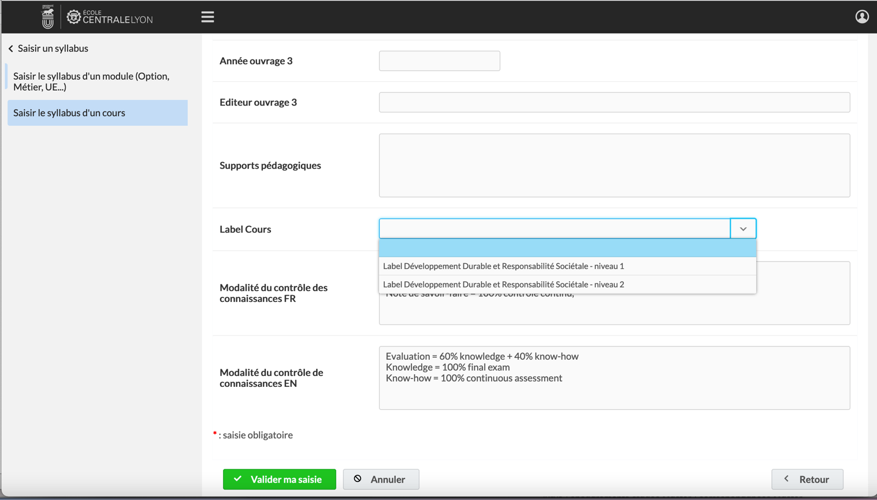

The criteria used to determine the level of certification are as follows:
- Level 0 (no label) = the activity has no connection with DD&RS issues (neither with regard to the objects studied, nor with regard to the examples or applications envisaged).

Example: a FA consisting of purely technical practical activities, or a highly abstract methodological FA.
- Label Level 1: the subject of study is not specific to DD&RS (e.g. methodological course), but examples of application are chosen in connection with DD&RS issues.

Examples:

an AF of general algorithms, but whose TD or TP take examples in optimization of a network of transport or consumption of electric energy,

an economics AF, which looks at the social impact of choices made in certain CMs,

a mechanical engineering AF where eco-design issues are raised in a design office.
- Level 2 label: certain activities are focused on an SD&RS issue (even if the whole activity is not).

Examples:

A practical course on photovoltaic energy

A green vehicle project,

.

- Label Level 3: the object of study is centered on an SD&RS issue (even if the activity also develops methodological aspects).

Examples:
- an AF on wind power,
- an AF on Green IT,
- an AF on ethics.

Please note. Recent studies suggest that very few activities are positioned at level 0.

